Practice Questions

MCQs

Which of the following is a non-linear equation?

(a) 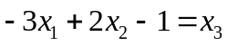
(b) 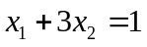
(c) 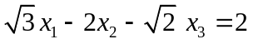
(d) 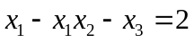

Which of the following is the coefficient matrix for the system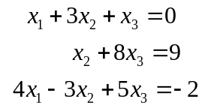 ?
(a) 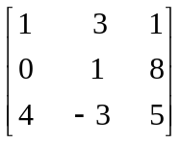
(b) 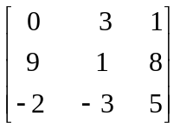
(c) 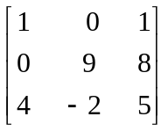
(d) 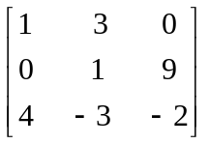

Short

Question No. 1. Is 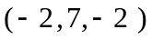a solution of the following linear system? If not then give the reason.
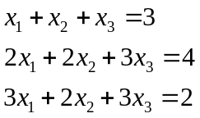

Question No. 2. Write a system of linear equations corresponding to the following augmented matrix:
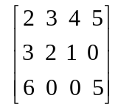

Question No. 3. Write augmented matrix of the following linear system. Also determine whether the system is consistent or inconsistent?
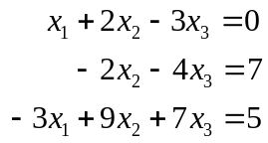

Long
Question No. 4. If 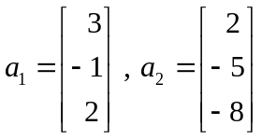 and 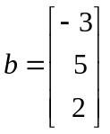 ; then Span 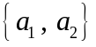 is a plane through the origin in 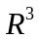. Determine whether is in that plane?

